


Multi-Functional Cane

ELBC803- Embedded Design Project
By

Ali Yazbeck – 94764
Serena Haidar – 90457
Zein Attar - 94266

Submitted to the Faculty of Engineering of the
Islamic University in Lebanon
Baalbek, Lebanon
In partial fulfillment of the requirements for the degree of

BACHELOR OF ENGINEERING IN COMPUTER AND COMMUNICATIONS
Spring 2024-2025

Approved by:
Dr. Mohammad Chreif

TABLE OF CONTENTS

CHAPTER 1 INTRODUCTION 1
CHAPTER 2 System Design and Implementation 3
2.1 Introduction 3
2.2 Required Components 3
2.3 Circuit Design 4
2.4 Implementation Steps 5
CHAPTER 3 Conclusion and Future Work 8
3.1 Conclusion 8
3.2 Future Work 8

LIST OF FIGURES

Figure ‎2-1 Complete circuit 5
Figure ‎2-2 Circuit 5
Figure ‎2-3 Led connections 6
Figure ‎2-4 Connecting Arduino to breadboard 6

INTRODUCTION

What Is Engineering?
Engineering is the disciplined art of applying scientific and mathematical principles to design, build, and optimize structures, systems, and processes for humanity’s benefit [1]. Fundamentally, engineering solves real-world problems, serving people and the planet alike, and propelling society forward [2].
The field branches into specialties such as biomedical, chemical, electrical, civil, materials, and mechanical engineering, each addressing unique challenges from health to infrastructure to energy. Beyond these fields, emerging and interdisciplinary domains, like environmental, aerospace, software, and mechatronics, illustrate engineering’s boundless reach across modern life [3].
Yet all engineers share a common framework: define requirements, model solutions, test prototypes, and refine designs until form and function unite seamlessly.

Project Idea and Objectives
Globally, over 2.2 billion people live with a near or distance vision impairment or blindness. Alarmingly, at least 1 billion of these cases are treatable or preventable, highlighting a profound need for assistive technologies [4]
Vision loss often leads to reduced independence, limited mobility, and an increased risk of accidents, especially when navigating new environments.
Today, existing mobility aids like traditional white canes, often rely on mechanical contact feedback. More advanced versions offer vibration alerts or audio cues, yet neglect hazards like water puddles, low-light visibility, or emergency signaling. These limitations leave visually impaired people vulnerable in critical situations.
To bridge this gap, our project presents a Multifunctional Smart Cane: an integrated assistive system designed to extend the capabilities of traditional canes using embedded technology.
Key features:
- Ultrasonic sensors to detect nearby solid obstacles
- A water sensor to identify slippery surfaces like puddles
- A GPS + GSM module to allow users to send location-tagged SOS messages in emergency cases
- An LDR-based lighting system that activates a bright LED in dark environments to increase user visibility
- A digital compass and sound module intended to provide directional orientation cues
- A rechargeable Li-ion battery system, ensuring portable, long-lasting operation.

Project Objectives:
- Detect obstacles and slippery surfaces: Using ultrasonic sensors for solid objects and a water sensor for puddles.
- Enable Emergency response: One-button system sends GPS coordinates via SMS using GSM module.
- Improve visibility in low-light: Automatic LED activation triggered by an LDR sensor to make the user visible to others.
- Assist with basic directional navigation: A digital compass paired with sound feedback to help orient the user.
- Ensure long-lasting operation: Powered by a rechargeable Li-ion battery for portability and efficiency.

By delivering these features, we address the fundamental challenges of safety, independence, and confidence for visually impaired users.

What Is the Arduino Mega 2560?
The Arduino Mega 2560 is a high-performance microcontroller board built around the ATmega2560 chip. It is designed for projects that require numerous inputs and outputs or complex control systems. With 54 digital I/O pins, 16 analog inputs, and 4 serial communication ports, it is well-suited for advanced embedded and automation projects, robotics, and large-scale sensor networks. [5]
Unlike boards with integrated wireless capabilities, such as the ESP32, the Mega 2560 relies on external modules (e.g., Bluetooth, GSM, or Wi-Fi) to extend its connectivity. It remains a popular choice for developers who prioritize pin availability and processing stability in large projects.
Arduino Mega 2560 Specifications [6]
- Microcontroller: ATmega2560
- Operating Voltage: 5V
- Input Voltage (recommended): 7–12V
- Input Voltage (limits): 6–20V
Memory
- Flash Memory: 256 KB (8 KB used by the bootloader)
- SRAM: 8 KB
- EEPROM: 4 KB
Digital and Analog I/O
- Digital I/O Pins: 54 (15 with PWM output capability)
- Analog Input Pins: 16
- PWM Channels: 15
- UARTs: 4 hardware serial ports
- Interfaces Supported: SPI, I2C, USB
Clocks and Timers
- Clock Speed: 16 MHz (external crystal oscillator)
- Timers: Includes hardware timers for PWM, timing, and interrupts
Others Features
- ICSP header for direct microcontroller programming
- Reset button, voltage regulator, and power jack
- Compatible with standard Arduino shields and the Arduino IDE

System Design and Implementation

Introduction
In this chapter, we present the components used in the Multi-Functional Smart Cane and the systematic steps followed for its implementation.
The main goal of this system is to assist visually impaired people in navigating their surroundings safely and independently by integrating sensors and modules for obstacle detection, location tracking, darkness detection, and emergency messaging.

Required Components
The following table lists all the components used to build the multi-functional smart cane. Each part was chosen based on its compatibility with the Arduino Mega 2560 and its relevance to the features we wanted to implement.

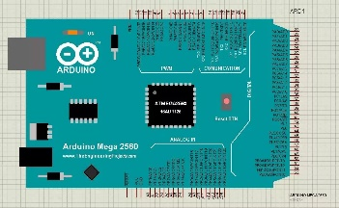 | ARDUINO MEGA-2560 x1  The brain of the system.
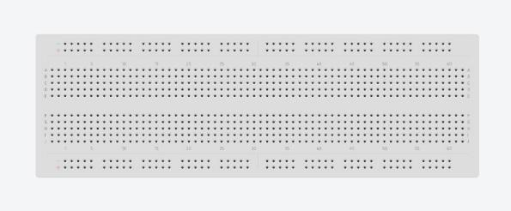 | Breadboard x1  For connecting components
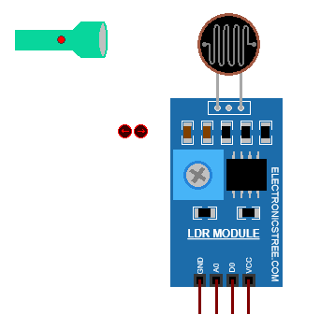 | LDR Sensor x1  Detects light intensity to automatically turn on a LED when it’s dark
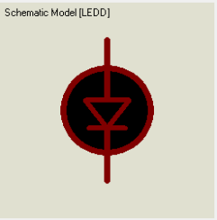 | LED Light x1  Lights up the path in dark areas based on the LDR readings
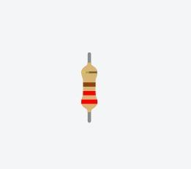 | Resistor 220-ohm x7  To implement electrical resistance as a circuit element
Potentiometer x1
To measure electric potential
Temperature sensor x1
To measure the amount of heat energy or even coldness that is generated by an object or system
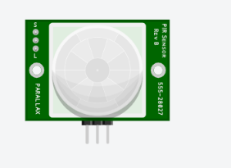 | PIR sensor X1

Circuit Design
Figure 2.1 shows the full circuit schematic of the system, which includes the Arduino Mega 2560 microcontroller, ultrasonic sensors, a GPS and GSM modules for emergency functionality, and other components connected with proper power management and grounding.
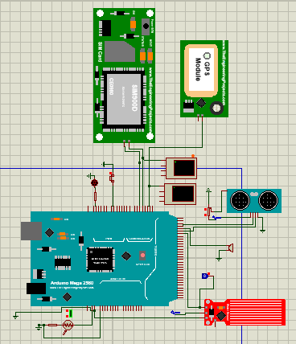
Figure ‎2.1 Full System Circuit Design

Implementation Steps

2.4.1 LDR Sensor

In this step, an LDR sensor is connected to the analog pin A0 and a LED to digital pin A8 on the Arduino Mega 2560. When the LDR detects darkness (light level gets below a set threshold), the Arduino turns on the LED automatically. This feature helps the user walk safely in low-light environments by turning on the light without any manual input.

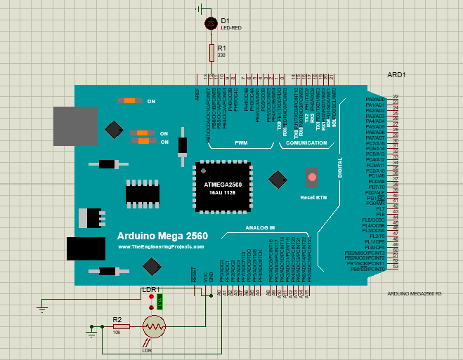
Figure ‎2.2 LDR and LED light circuit connected to Arduino Mega 2560

Arduino Code:
int ldrPin = A0; // LDR connected to analog pin A0
int ledPin = 8; // LED connected to digital pin 8
int threshold = 500; // Light threshold for darkness
void setup() {
pinMode(ledPin, OUTPUT);
Serial.begin(9600);
}
void loop() {
int lightLevel = analogRead(ldrPin); // Read light value
if (lightLevel < threshold) {
digitalWrite(ledPin, HIGH); // Turn on LED
} else {
digitalWrite(ledPin, LOW); // Turn off LED
} }

Explanation
- analogRead(): reads the light level from the LDR.
- If the value is less than 500 (dark), the LED turns on.
- If it's brighter, the LED stays off.
This ensures safer navigation for the user in the dark, making them more visible to others.

2.4.2 GPS+GSM modules

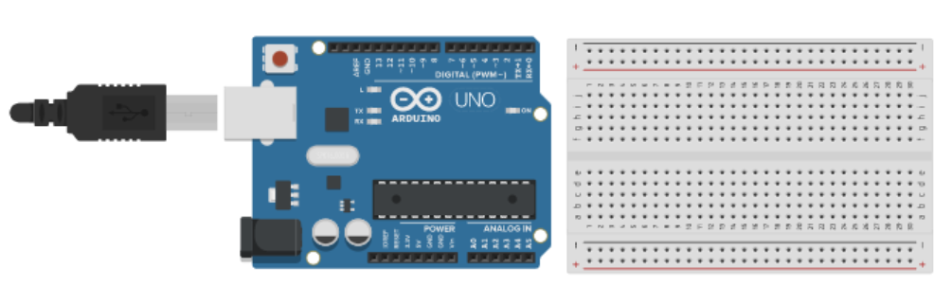
Figure ‎2-3 Connecting Arduino to breadboard

Conclusion and Future Work

Conclusion
In this paragraph, you write a summary of what you presented in the above two chapters. Instead of using expressions like “in our project we will implement ….”, in the conclusion we usually use expressions like “As we could see above, in our project we implemented ……”.
Besides, you need to write about the experiences you learned while taking the course and implementing the project.

Future Work
In this paragraph, you need to write any idea you have about expanding the work you did in your project to be more developed and to be used in real life.

References

[1] | R. J. Smith, "Britannica," 28 Apr 2025. [Online]. Available: https://www.britannica.com/technology/engineering. [Accessed 8 May 2025].
[2] | A. C. o. E. Companies, "ACEC," Yoko Co, 2025. [Online]. Available: https://www.acec.org/about-acec/what-is-engineering/. [Accessed 13 May 2025].
[3] | N. University, "National University," 2025. [Online]. Available: https://www.nu.edu/blog/types-of-engineering/#15-different-types-of-engineering-jobs. [Accessed 13 May 2025].
[4] | W. H. Organization, "World report on vision," World Health Organization, 2019.
[5] | "Arduino Store," [Online]. Available: https://store.arduino.cc/products/arduino-mega-2560-rev3. [Accessed May 2025].
[6] | "Arduino Docs," [Online]. Available: https://docs.arduino.cc/hardware/mega-2560/. [Accessed May 2025].

